PROJECT REPORT

INTRODUCTION

Overview:

3**.tips for writing the perfect description for tours and travels**

### 1.Find your Unique Selling Proposition  (USP)

### Competition is only natural within the experiences industry. With so many other businesses providing similar tours and activities, it’s sometimes hard to stand out from your competitors. On the other hand, having so many similar options available at once may be overwhelming for many customers. Most of the time, customers want to quickly understand what makes one service different from the others. Having a clear differentiation, allows them to make a swift and efficient booking.

You can help your customers by promoting your business’s unique selling

### 2. Find a persona for your tour description

Target a specific persona before you begin writing. For example, if you are a company that provides kayak tours to experienced adventurers, then develop a persona that addresses your target audience. It might be an open-minded person who has the necessary skills to kayak and enjoys the thrill of a new experience. You need to think about who will most likely book your tour business, think about your ideal customers, and break up the details of your tour description for a persona that identifies with that audience.

### 3. Make an easy to read description for tours and travels

Make sure your tour description is easy to read by:

* Avoiding long, wordy sentences that can be cumbersome;
* Making every word count, and choosing powerful action verbs to describe the experience;
* Instead of writing a paragraph about each tour that you offer, create several bullet points. Bullet points are easier to scan through and will allow you to keep your reader’s attention.

**Purpose:**

The number of data sources, TRAVELTRAX has analyzed over"Data is key for corporations to understand where their money has TRAVELTRAX, with connections to all of the major corporate card issuers, credit card associations, GDSs, TMCs, HR systems and key direct connect vendors, has the unique ability to aggregate and enhance data from virtually any source and to provide actionable intelligence to travel and procurement managers resulting in significant cost savings.

been spent but more importantly where their money could be better spent," said Kevin Austin, Executive Vice President - TRAVELTRAX, TRX. "Our unmatched record in the number of data connections, deployments, and users, coupled with our vast report library containing thousands of reports, and our ability to further customize these reports based on the individual needs of our clients makes TRAVELTRAX the most widely-used independent reporting platform today." Corporate buyers face a number of difficult issues when managing their T&E expenses such as airline ancillary fee spend, channel compliance, and travel policy adherence," said Shane

***Problem Definition & Desigen Thinking***

**Empathy Map:**

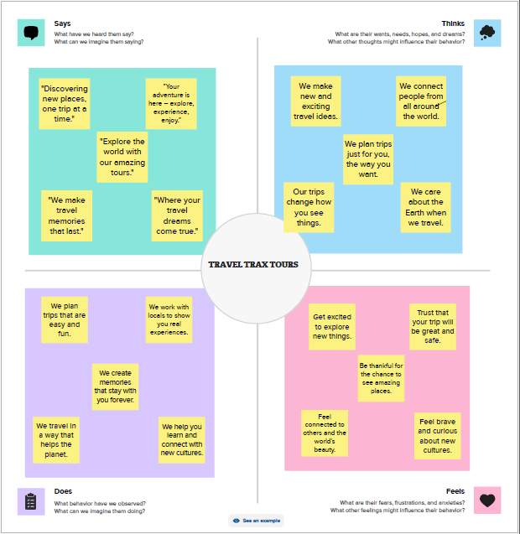

**Ideation & Brainstorming map:**

ide

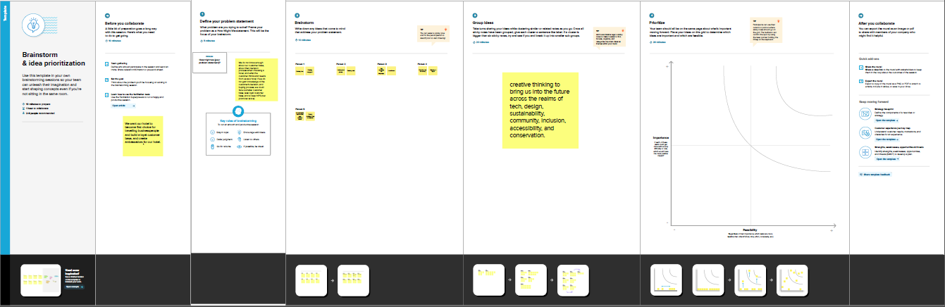

***RESULT***

#### **Travel Trax Tour**

### Horizontal Balance Sheet

### Basis: Accrual

As of 10.12.23

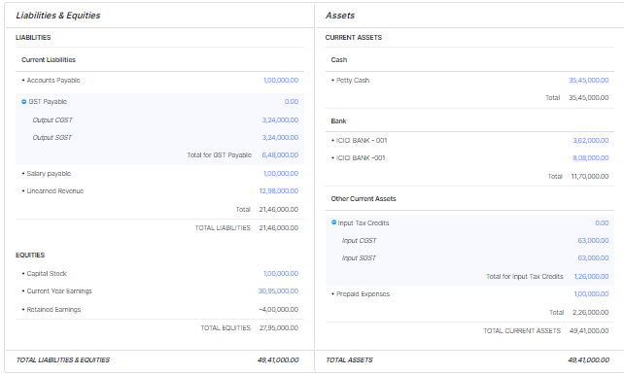

***ADVANTAGES & DISADVANTAGES***

Advantages

* A typical tour package will usually include plenty of destinations. Chances are that going to all these places on your own would cost a lot more, mainly because travel agents and tourism companies have good connections with the hotels and transportation companies, and also because they get maximum discounts for sending groups rather than individuals or single families
* One of the biggest advantages is of course the convenience. As earlier suggested, planning for a full-fledged trip and visiting various places will take quite a lot of planning and due diligence. But when you opt for a tour package, you can just sit back and relax — at least as far as planning is concerned.
* You will be able to relax and enjoy your travel and the places without having to worry about the tickets, and hotel reservations in your next stop.
* Tour packages can be a great option when you are looking to plan a honeymoon or travel with your family. A poorly planned trip can be quite embarrassing as well as stressful; therefore, going with a reputable travel company might be a safer option.

***DISADVANTAGES***

* The biggest disadvantage of a tour package is the lack of control. You need to follow the guidelines and a strict schedule. You cannot extend your stay in a certain place even if you love it. Similarly you cannot move to the next place if there’s nothing to be excited about, before the scheduled time.
* You need to be extra careful while choosing one of these packages. The aforementioned advantages can easily turn into disadvantages if you don’t choose the right company Safety is another big advantage of tour packages.
* When you are doing the planning, and choosing the destinations or activities to do, you might pick out a place or activity that might have some potential risks that you’d rather avoid. Travel companies know places inside out, and they will usually choose risk-free destinations and activities, keeping in mind the age and preferences of the participants.

***APPLICATIONS***

* TRAVELTRAX® helps over 6,000 corporations gain a better understanding of corporate travel data and more effectively manage their global T&E costs.
* Fortune 500 corporations manage large and complex travel and procurement programs and need clear insight into their T&E spend in order to better administer and drive costs out of these programs. In a digital economy with multiple sources of data that can make disintermediation a serious challenge, clear insight is difficult to obtain.
* TRAVELTRAX, with connections to all of the major corporate card issuers, credit card associations, GDSs, TMCs, HR systems and key direct connect vendors, has the unique ability to aggregate and enhance data from virtually any source and to provide actionable intelligence to travel and procurement managers resulting in significant cost savings.
* "Data is key for corporations to understand where their money has been spent but more importantly where their money could be better spent," said Kevin Austin, Executive Vice President - TRAVELTRAX, TRX. "Our unmatched record in the number of data connections, deployments, and users, coupled with our vast report library containing thousands of reports, and our ability to further customize these reports based on the individual needs of our clients makes TRAVELTRAX the most widely-used independent reporting platform today."
* "Corporate buyers face a number of difficult issues when managing their T&E expenses such as airline ancillary fee spend, channel compliance, and travel policy adherence," said Shane Hammond, President and CEO, TRX. "It's easy to understand why firms like Hitachi, Gilead and Visa, all recent client additions, see great value in TRAVELTRAX, no other solution can aggregate and normalize the number of data sources, TRAVELTRAX has analyzed over $35 billion in spend last year which resulted in hundreds of millions of dollars of savings for our clients."

***CONCLUSION***

* **Association of Canadian Travel Agencies (ACTA):** a trade organization established in 1977 to ensure high standards of customer service, engage in advocacy for the trade, conduct research, and facilitate travel agent training
* **Canada’s West Marketplace:** a partnership between Destination BC and Travel Alberta, showcasing BC travel products in a business-to-business sales environment
* **Canadian Association of Tour Operators (CATO):** a membership-based organization that serves as the voice of the tour operator segment and engages in professional development and networking in the sector
* **Community destination marketing organization (CDMO):** a DMO that represents a city or town
* **Destination management company (DMC):** a company that creates and executes corporate travel and event packages designed for employee rewards or special retreats

**Destination marketing organizations (DMOs):**also known as destination management organizations; includes national tourism boards, state/provincial tourism offices, and community convention and visitor bureaus

* **Familiarization tours (FAMs):** tours provided to overseas travel agents, travel agencies, RTOs, and others to provide information about a certain product at no or minimal cost to participants — the short form is pronounced like the start of the word family (not as each individual letter)

***FUTURE SCOPE***

The **India - travel services market**size is estimated to grow at a **CAGR of 11.72%** between 2022 and 2027. The market size is forecast to increase by **USD 13,462.48 million**. The growth of the market depends on several factors such as the increase in the number of M&A, partnerships, and strategic alliances, the increasing international tourist footfall, and the rising adoption of online payment platforms.

This India travel services market report extensively covers**market segmentation by mode of booking (online and offline) and service (domestic flight services, hotel accommodation services, rail ticket services, cab services, and others).** It also includes an in-depth analysis of drivers, trends, and challenges. Furthermore, the report includes historic market data from 2017 to 2021.

## India Travel Services Market Customer Landscape

The market research report includes the adoption lifecycle of the market, covering from the innovator’s stage to the laggard’s stage. It focuses on adoption rates in different regions based on penetration. Furthermore, the report also includes key purchase criteria and drivers of price sensitivity to help companies evaluate and develop their growth strategies.

The research report also includes detailed analyses of the competitive landscape of the market and information about 20 market companies, including:

* ANI Technologies Pvt. Ltd.
* Booking Holdings Inc.
* Cleartrip Pvt. Ltd.
* Cox and Kings Ltd.
* Easy Trip Planners Ltd.
* Expedia Group Inc.
* Indian Railway Catering and Tourism Corp. Ltd.
* ITC Ltd.
* Kesari Tours Pvt. Ltd.
* Le Travenues Technology Ltd
* Mahindra and Mahindra Ltd.
* MakeMyTrip Ltd.
* Oravel Stays Ltd.
* The Travel Corp
* Thomas Cook (India) Ltd.
* Treebo Hotels
* TripAdvisor Inc.
* Uber Technologies Inc.
* Yatra Online Inc.

Data is qualitatively analyzed to categorize companies as pure play, category-focused, industry-focused, and diversified; it is quantitatively analyzed to categorize companies as dominant, leading, strong, tentative, and weak.

***APPENDIX***

[***https://books.zoho.in/app/60024322011 - /home/announcement***](https://books.zoho.in/app/60024322011#/home/announcement)